Skip Records

The ‘Skip Records’ can be enabled either by inputting a ‘0’ on the record count section under the filters or either by selecting the ‘checkbox’ under the ‘Skip Records’ section.

To enable ‘Skip Records’ through the ‘Filters’, click on the filters. The ‘Skip Records’ skip migrating an object to the destination.

Please input ‘0’ on the ‘Record Count’ filed of the ‘Apply Filters’ page popped-up and click on ‘Validate’ to validate the query.

On completing the validation, click on the ‘Apply’ button to apply the inputs.

Please select the checkbox, to “Skip Records” from migrating to the destination.

On selecting the checkbox, a pop-up will be displayed with a message asking for confirmation.

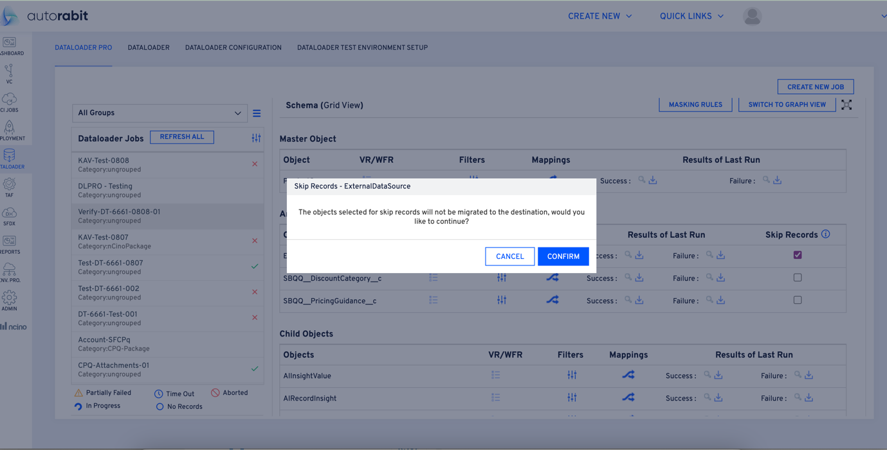

On confirming, the checkbox will be checked to not to migrate the records to the destination. With the following notification on filters applied.

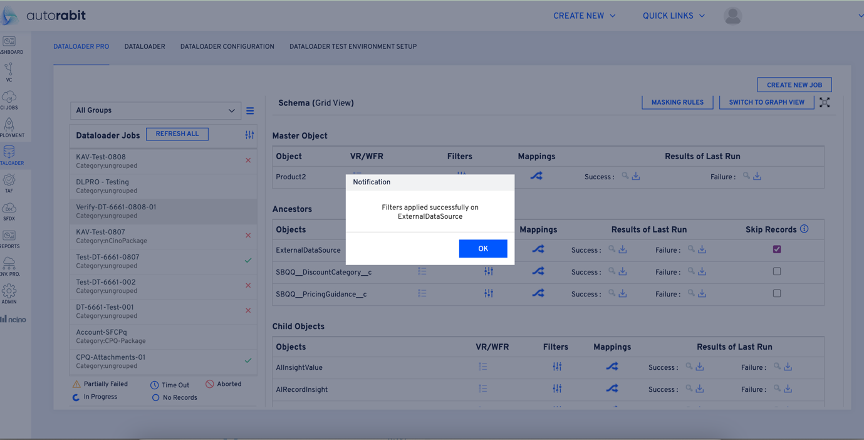

Click on the filters section of the object on which the “Skip Records” is applied, to observe the query builder and the “Record Count”.

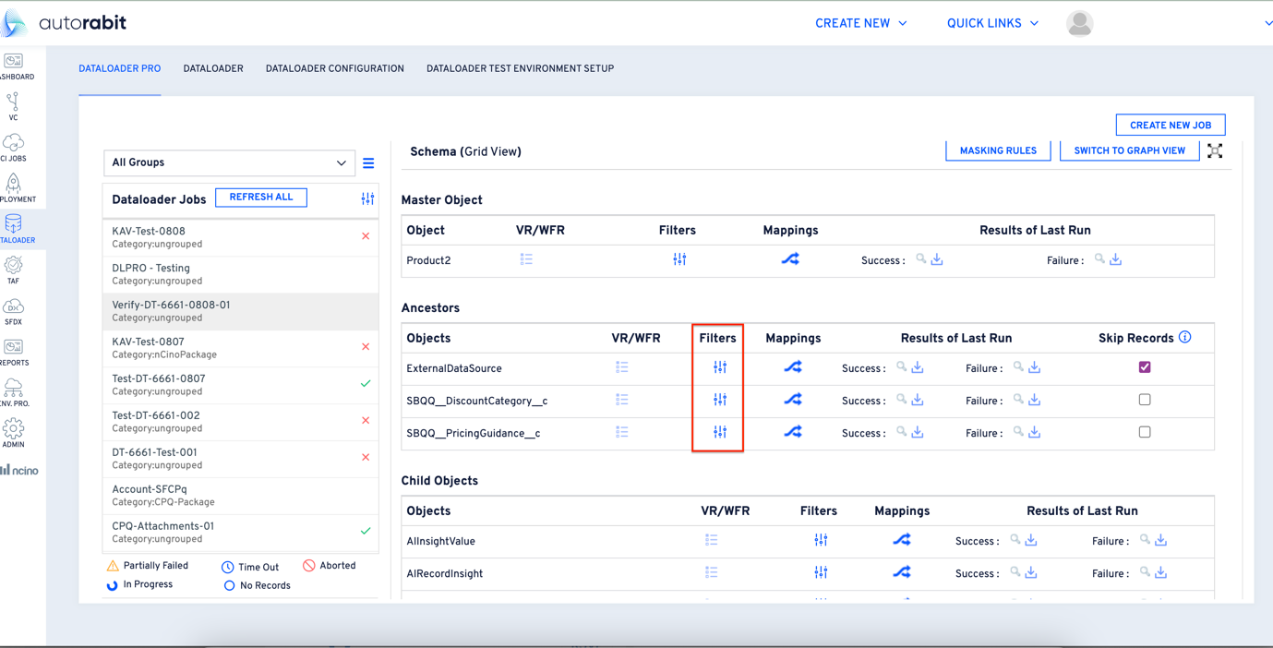

As the ‘Skip Records’ are applied, the record count would be set to ‘0’, the records from the selected object will not be migrated to the destination.

On unchecking the ‘checkbox’, the skip records will be disabled on the object. The following message will be displayed asking for confirmation.

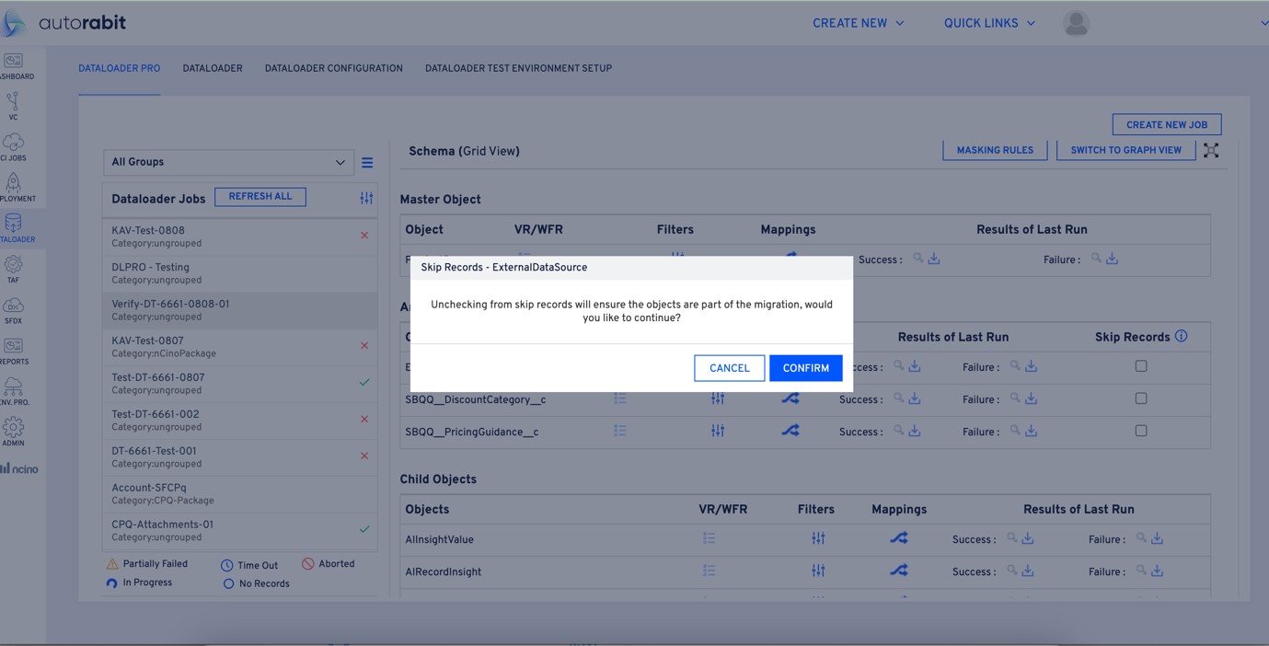

On clicking on the confirm, the records from that particular object will be migrated to the destination. The following notification can be observed on unchecking the checkbox.

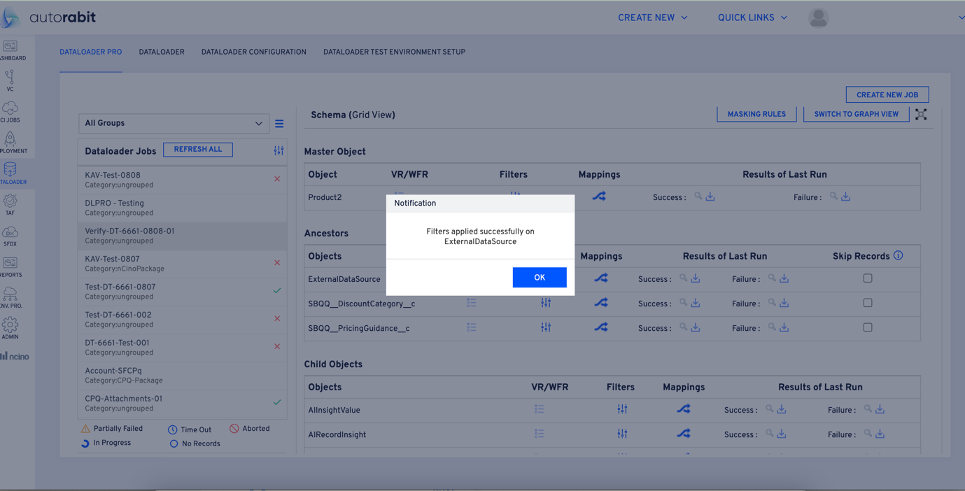

As the ‘Skip Records’ is disabled, the record count which is set to ‘0’ in the filters and the query will be reset to blank. So, the records will be migrated to the destination.